Tabella firewall
Schema logico
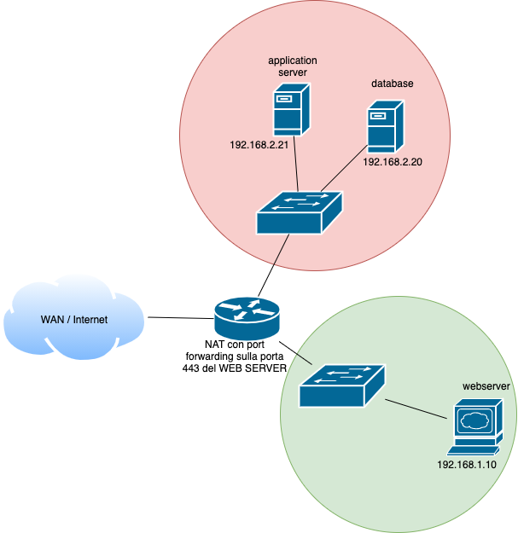

Regola | Azione | Source address | Dest  address | Source port | Dest port
1 | ALLOW | ANY | 192.168.1.10 | ANY | 80
2 | ALLOW | 192.168.1.10 | ANY | 80 | ANY
3 | ALLOW | 192.168.1.10 | 192.168.2.21 | ANY | ANY
4 | ALLOW | 192.168.2.21 | 192.168.1.10 | ANY | ANY
5 | BLOCK | ANY | ANY | ANY | ANY

